Paper Title (Times New Roman, 14 point-bold, Center)
First A. Author¹⁾, Second B. Author²⁾, and Nth N. Author^{n),†} (Times New Roman, 10 point, Center)
¹⁾author’s affiliation, …, n) author’s affiliation (Times New Roman, 10 point, Italic, Center)
† corresponding author : e-mail address (Times New Roman, 10 point, Center)

Abstract

Abstract should be written in one page including Figure, Table, and References in Times New Roman, 9 point. (Please submit only 150 words)

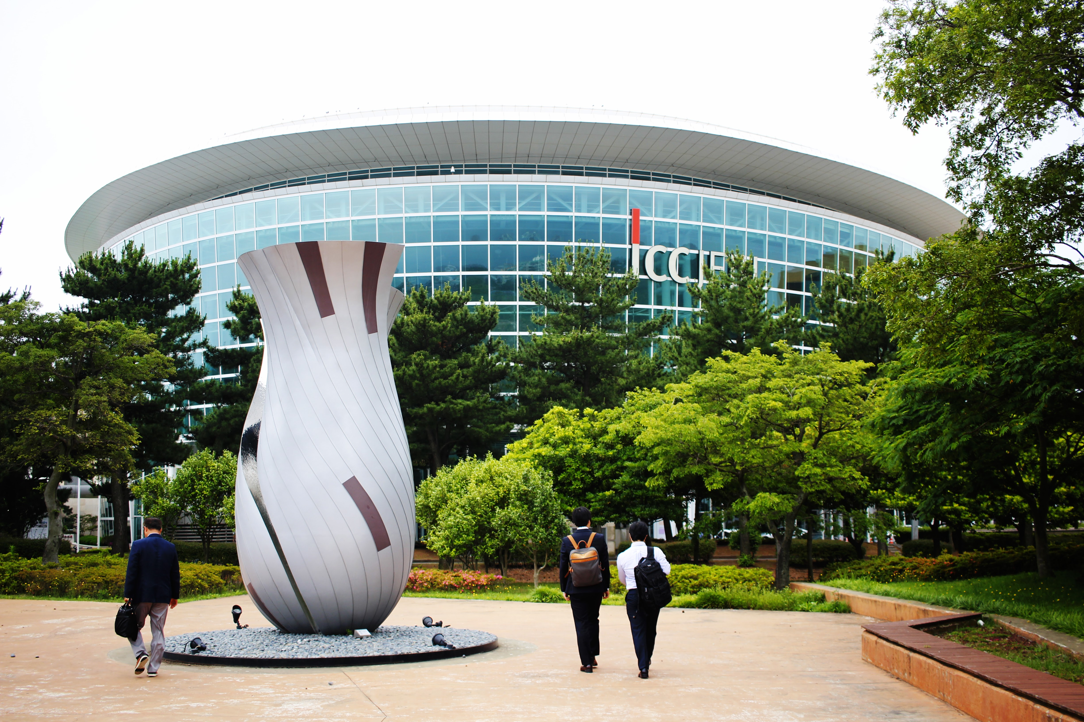
ICC (Times New Roman 9-point bold)

Key Words : 3~5 words (Times New Roman, 9-point-bold)
References (Times New Roman, 9 point-bold)
[1] S. S. Lee, S. J. King, and G. Kim, “Feel free to contact NBSIS”, J. SPIE NBSIS., Vol. 82, No. 6, pp. 5290-5295, 2010
[2] G. W. Bush and S. Hussein, The way to peaceful world, John Wiley & Daughters, Dallas, pp. 237-242, 2011
[3] A. Hitler and B. A. A. Mussolini, “I shouldn’t have done that”, Proc. of IEEE Conf. on Regret and Repentance in Hell, pp. 1939-1945, Confessional, Inferno, 2006

